Aurora's Higher Education and Research Academy
Uppal, Hyderabad, Telangana, +91 9100123456, aurora.edu.in
DEPARTMENT OF COMPUTER SCIENCE AND ENGINEERING – DATA SCIENCE
COMPREHENSIVE PROJECT REPORT

FOUNDATIONS OF DATA SCIENCE

PROJECT TITLE
VISUAL ANALYTICS OF CLIMATE CHANGE DATA
LEARNING GROUP NO: 08
INTERNAL GUIDE: Mr. Pranay Vemula, Assistant Professor, Dept. of CSE

NAME: Manasa Gaddam
ROLL NO: 241U1R3007
Mob num: 8988199666
Email id: manasa.gaddam@aurora.edu.in

NAME: Sreesha Thummalapalli
ROLL NO: 241U1R3013
Mob num: 9052126897
Email id: Sreesha.thummalapalli@aurora.edu.in

NAME: Merupula Mokshesh Goud
ROLL NO: 241U1R3014
Mob num: 8499856776
Email id:

Aurora's Higher Education and Research Academy
Uppal, Hyderabad, Telangana, +91 9100123456, aurora.edu.in

DEPARTMENT OF COMPUTER SCIENCE AND ENGINEERING – DATA SCIENCE

DECLARATION BY THE CANDIDATE

I, Sreesha Thummalapalli bearing Registration Number 241U1R3013, hereby declare that the project report entitled “Visual Analytics of Climate Change Data” under the guidance of Mr. Pranay Vemula, Department of Computer Science and Engineering, Aurora’s Higher Education and Research Academy, Uppal is submitted in partial fulfillment of the requirements for the award of the degree of B.Tech in Computer Science and Engineering – Data Science.

This is a record of Bonafide work carried out by me and the results embodied in this project have not been reproduced or copied from any source. The results embodied in this project report have not been submitted to any other university or institute for the award of any other degree or diploma.
Name: Sreesha Thummalapalli
Reg. No.: 241U1R3013
Aurora's Higher Education and
Research Academy
Uppal, Hyderabad
Aurora's Higher Education and Research Academy
Uppal, Hyderabad, Telangana, +91 9100123456, aurora.edu.in

CERTIFICATE

This is to certify that the Comprehensive Project report entitled “Visual Analytics of Climate Change Data” submitted by Ms. Sreesha Thummalapalli bearing Registration Number 241U1R3013 for the fulfillment of the successful completion of Foundations of Data Science Course in II Year I Term of B. Tech Program at Aurora’s Higher Education and Research Academy, is an authentic compilation of her efforts, completed under our guidance. We also commend their dedication and effort.

Internal Examiner Head of the Department External Examiner

ACKNOWLEDGMENT

I am very pleased to present this major Project report. This period of my student life has been truly rewarding several people were of immense help to me during my research and the preparation of my Comprehensive project report.
First, I wish to thank God Almighty who created the heavens and earth and helped me in completing this project.
I thank my parents who encouraged me to continue my Undergraduate studies, to my father and mother.
I would like to thank Mr. Pranay Vemula, Aurora’s Higher Education and Research Academy, Uppal, my project internal guide, for his guidance and help. His insight during the course of my research and regular guidance were valuable to me.
And also, I thank Dr. S. Mahesh, Head of the Department, Computer Science and Engineering – Data Science, Aurora’s Higher Education and Research Academy, Uppal, for her encouragement and cooperation throughout the project.
I would also thank Dr. Vishwanadham Bulusu, Registrar of our University, for extending his help.
I would also thank Dr. Aruna, Dean of Engineering of our University, for extending her help.

ABSTRACT

Climate change is a big deal for our planet and we get a lot of information about it from different places like reports on the environment, special sensors and websites. It is hard to look at all this information using the ways because there is just so much of it. It is very complicated. This project is, about using Visual Analytics of Climate Change Data to understand climate change. We do this by using techniques to analyze the climate change data and then we use tools to visualize the climate change data so we can see the patterns and trends of climate change more clearly. The goal is to understand climate change and its patterns and trends. The project collects climate-related data such as temperature, rainfall, and carbon emissions, processes and cleans the data, and analyzes it to identify important changes over time. Visual tools like graphs, charts, and maps are used to present the results in an easy and meaningful way. The visual analytics approach helps users quickly observe trends, compare data, and gain useful insights into climate change. This project supports better awareness, understanding, and decision-making related to environmental and climate issues.

LIST OF FIGURES

S.NO. | NAME OF THE DIAGRAM | PAGE NO.
1. | Architecture Diagram | 14
2. | E-R Diagram | 14
3. | Test Cases | 20

LIST OF TABLES

S.NO. | NAME OF THE TABLE | PAGE NO.
1. | Literature survey on current Objectives | 6

SNO. | CONTENT | PAGE NUMBER
1 | Introduction | 1
1.1 | Background Knowledge | 1
1.2 | Motivation for the project | 1
1.3 | Existing System | 2
1.4 | Problem Statement | 3
1.5 | Objectives of the proposed Model | 4
1.6 | Limitations | 5
2 | Literature Survey | 6
2.1 | State of art of the proposed model | 6
3 | Project Requirement | 10
3.1 | Software requirements | 10
3.2 | Hardware Requirements | 10
3.3 | Functional requirements | 10
3.4 | Non-functional requirements | 11
4 | Project Design | 14
4.1 | Architecture Diagram | 14
5 | Methodology | 15
6 | Coding | 16
7 | Testing and results | 20
7.1 | Sample inputs and outputs | 20
7.2 | Discussion on results | 21
8 | Creativity and Innovation | 22
9 | Community Impact | 23
10 | References | 24
INDEX

1. INTRODUCTION
1.1 BACKGROUND KNOWLEDGE
Climate change is when the weather gets different over a time. This means things like the temperature and the amount of rainfall and the seasons are not the same as they used to be. Climate change happens because of things that people do.
All of these things cause problems, with the climate. Climate change causes warming and big floods and long droughts. It also causes the ice to melt and the sea levels to rise. Climate change is an issue because it affects the weather and the earth in many ways. Today we get a lot of climate data from weather stations, satellites and the internet. The climate data we get includes things, like temperature how much it rains, how polluted the air is and the amount of carbon emissions. The thing is, the climate data is really big so it is tough to make sense of it using the ways. Visual analytics is really helpful because it shows us data in a way like graphs and charts and maps. This makes climate data easy to understand. We can compare it. Using analytics people can see climate changes and patterns over time which is very clear. Visual analytics helps us to see what is happening with the climate.

1.2 MOTIVATION FOR THE PROJECT
Climate change is an issue that affects the life of every single person. A lot of people are hearing about climate change. They have a hard time understanding it because there is just so much information. The numbers and tables that are used to explain climate change are. They do not really show what is going on with the climate. Climate change is something that needs to be made clear, to everyone so people can see what is happening to the climate. Understand the problem of climate change. The reason we are doing this project is to make climate change data simple for people to understand. We are using pictures and graphs to do this. Climate change data is easier to see when we use graphs, charts and maps. These things help people see what is happening with the temperature, rainfall and pollution levels quickly. Climate change data is hard to understand when it is a bunch of numbers.. When we use visuals like graphs and charts it is easier to see what is going on. Visuals are better than looking at climate change data because they show us what is happening over time. They clearly show the trends and patterns, in climate change data.
This project is also motivated by the need to create awareness about climate change. When people can see climate changes visually, they understand the problem better and feel encouraged to take action. The project helps students, researchers, and decision-makers to analyze climate data and make better decisions for protecting the environment.

1.3 EXISTING SYSTEM
Climate change data is usually shown in tables, reports and documents. Scientists and organizations gather climate change data. Put it in databases or release it as reports. To understand climate change data you need to know a lot about it and be able to analyze it which is hard for people who are not experts, in climate change data. Climate change data is really important. It is not easy for everyone to understand climate change data.
Most of the methods that people use now are pretty simple. They use statistics and people have to look at the data by hand. If they do use pictures to help understand the data it is simple graphs and you cannot do anything with them. The people who are using the data cannot easily look at it compare what happened in years or focus on specific areas, like a certain city or region.
The existing system also lacks real-time updates and proper integration of data from different sources. Because of these limitations, it becomes hard to clearly understand climate trends and patterns. As a result, awareness and effective decision-making about climate change are reduced.

1.4 PROBLEM STATEMENT
Climate change data is around us but it is really hard to make sense of it. The thing is, most climate change data comes to us in the form of numbers and tables and long reports. These numbers and tables and reports are very confusing, for students and regular people who want to learn about climate change data. Climate change data is not easy to understand when it is presented in this way.
We do not have a system that can take climate information from places and show it to us in a simple way. This means we cannot easily see the things about the climate like patterns and changes in the climate and trends in the climate. The climate trends and the climate patterns are not clear, to us because of this.
The problem is to design a system that uses visual analytics to convert complex climate change data into simple graphs, charts, and maps. This will help users easily understand climate trends, improve awareness, and support better decision-making related to environmental issues.

  - OBJECTIVES OF THE PROPOSED MODEL
The main objective of the proposed model is to use visual analytics to make climate change data easy to understand and useful for analysis. The model focuses on converting complex climate data into clear visual formats so that users can easily observe changes and trends.
- To collect climate-related data such as temperature, rainfall, carbon emissions, and pollution levels from different sources.
- To clean, filter, and organize the collected data to remove errors and unwanted information.
- To analyze the processed data to identify climate trends, patterns, and changes over time.
- To represent climate data using graphs, charts, maps, and dashboards for better understanding.
- To allow users to compare climate data across different years and regions.
- To improve awareness and understanding of climate change through clear visual representation.
- To support students, researchers, and policymakers in making better decisions related to climate and environment.
- To provide a user-friendly system that can be easily used even by non-technical users.

1.6 LIMITATIONS
- The project fully depends on climate data collected from different sources, and if the data is incorrect, outdated, or incomplete, the analysis results may not be accurate.
- Most of the data used in this project is historical data, so the system does not show real-time climate changes.
- Handling large climate datasets requires high processing power and memory, which may slow down the system.
- The accuracy of results depends on the analysis techniques and visualization tools used in the project.
- The system mainly focuses on data visualization and does not provide advanced climate forecasting or predictions.
- Some climate data sources may have limited access or restrictions, reducing data availability.
- Users need basic understanding of climate concepts to properly interpret some graphs and charts.
- The system requires a stable internet connection to collect, update, and manage online climate data.

2. LITERATURE SURVEY
2.1 STATE OF ART OF THE PROPOSED MODEL
The state of the art refers to the latest and most effective techniques currently used for analyzing and visualizing climate change data. Modern climate data analysis systems use advanced data processing, visualization, and analytical tools to handle large and complex datasets.
- Climate Data Collection:
Climate data is collected from satellites, weather stations, sensors, and online databases to monitor temperature, rainfall, and pollution.
- Big Data Handling:
Since climate data is very large, advanced data storage and processing tools are used to manage and analyze it efficiently.
- Data Analysis Techniques:
Modern systems use statistical methods and machine learning to find patterns, trends, and changes in climate data over time.
- Visual Analytics:
Visual analytics means showing data using graphs, charts, maps, and dashboards so that complex information becomes easy to understand.
- Geographical Visualization:
Climate data is displayed on maps to show how climate changes differ from one location to another.
- Interactive Dashboards:
Users can select years, regions, or parameters and explore climate data interactively.
- Real-Time Monitoring:
Some systems support real-time data updates to track current climate conditions.
- Proposed Model Approach:
The proposed model uses these modern techniques to provide a simple, user-friendly system that helps users understand climate change data easily.

2.2 LITERATURE SURVEY ON CURRENT OBJECTIVES
TITLE & AUTHORS OF THE PAPER | OBJECTIVE | METHODOLOGY | PERFORMANCE
1.Title: Visual Analytics - Climate Change in Social Media  Authors: Vanessa Kokoschka, Cristian A. Secco | - To study how people talk about climate change on social media.  - To find what kind of posts people share — positive, negative, or neutral.  - To see which topics, words, or hashtags are most common.  - To show the results clearly using charts and graphs. | Data Collection:  - Collect posts or tweets about climate change.  Data Cleaning:  - Remove extra symbols, links, and repeated posts to make the data neat.  Sentiment Analysis:  - Check whether people’s posts are positive, negative, or neutral about climate change.  Keyword Analysis:  - Find which words or hashtags are used the most.  - Show them using word clouds or bar graphs.  Visualization:  - Use tools like Python, Tableau, or Power BI to make:  - Graphs showing how people feel  - Charts showing most used hashtags  - Maps showing where posts come from  Result Study:  Look at the visuals to understand people’s opinions and awareness about climate change. | - Most people share positive and awareness-based posts about climate change.  - Common hashtags found were #ActOnClimate, #ClimateCrisis, and #SaveEarth.  - Engagement (likes, shares) increased during major climate events.  - The charts and visuals made the information easy to understand and useful for awareness.
2. Title: Media Watch on Climate Change -- Visual Analytics for Aggregating and Managing Environmental Knowledge from Online Sources  Authors: Arno Scharl  Alexander Hubmann-Haidvogel | - To collect climate change information from websites, news, and social media.  - To study what people and media are saying about climate and environment.  - To use visual tools like graphs and charts to show this information clearly.  - To help people understand and track climate change topics easily. | - Data Collection:  Collect data from news sites, blogs, and social media related to climate change.  - Data Cleaning:  Remove unwanted, repeated, or unrelated data.  Combine all data into one proper file.  - Data Analysis:  Use tools to check what topics are trending and how people feel (positive, negative, or neutral).  Find the most common keywords, hashtags, and themes about climate change.  - Visualization:  Use Tableau, Power BI, or Python to make:  Charts showing trends over time  Word clouds showing popular topics  Maps showing where the data comes from  - Knowledge Management:  Create an interactive dashboard so users can easily explore and understand the information. | - The system was able to collect and show online data about climate change clearly.  - It helped to see public opinions and news trends quickly.  - The visual charts made it easy to understand big data in a simple way.  - It can be made better by adding real-time updates and AI tools to analyze faster.
3. Title: Visual Analytics for Climate Change Detection in Meteorological Time-Series  Authors: Milena Vuckovic, Johanna Schmidt | - To analyze long-term meteorological time-series data such as temperature, rainfall, and humidity.  - To identify climate change patterns, trends, and anomalies using visual analytics techniques.  - To help researchers and policymakers understand climate variations through intuitive visual representations.  - To support data-driven decision-making for climate monitoring and environmental planning. | - Data Collection:  Historical meteorological time-series data (temperature, rainfall, etc.) is collected from reliable climate sources.  - Data Preprocessing:  The data is cleaned by handling missing values, removing noise, and normalizing values for consistency.  - Time-Series Analysis:  Statistical methods are applied to detect trends, seasonal patterns, and anomalies over time.  - Visual Analytics:  Interactive visualizations such as line charts, heatmaps, trend graphs, and anomaly plots are created to explore climate changes visually.  - Pattern Detection:  Visual comparisons across years and regions are performed to identify long-term climate change indicators. | - The system efficiently processes large meteorological datasets.  - Visualizations clearly highlight long-term climate trends and abnormal variations.  - Improves understanding of complex time-series data compared to numerical analysis alone.  - Enables faster detection of climate change signals with minimal computational overhead.  - Provides scalable performance for multi-year and multi-parameter climate datasets.
4. Title: Review – Visual Analytics of Climate Networks  Authors: T. Nocke et al. | - To review existing research on climate networks and their role in climate data analysis.  - To study how visual analytics techniques are used to explore and interpret climate network structures.  - To understand relationships and interactions among climate variables across different regions.  - To highlight the importance of network-based visualization in detecting climate patterns and anomalies. | - Climate Network Concepts:  Studies are analyzed to understand how climate networks are constructed from meteorological data using nodes and edges.  - Visual Analytics Techniques:  Different visualization methods such as network graphs, heatmaps, and temporal network views are examined.  - Comparative Analysis:  Various tools, techniques, and frameworks are compared based on effectiveness, usability, and analytical capability.  - Critical Evaluation:  Strengths, limitations, and research gaps in existing visual analytics approaches for climate networks are identified. | - Visual analytics improves interpretability of complex climate networks.  - Network-based visualizations enable efficient identification of teleconnections and climate interactions.  - Reviewed methods show effective performance in handling large-scale climate datasets.  - Visual exploration reduces analysis time compared to purely statistical approaches.  - Supports scalable analysis for multi-dimensional and long-term climate data.
5. Title: Visual Analytics Approach to Comprehensive Meteorological Time-Series Analysis  Authors: Milena Vuckovic, Johanna Schmidt | - To analyze large-scale meteorological time-series data using visual analytics techniques.  - To identify trends, seasonal patterns, and anomalies in weather parameters such as temperature, rainfall, humidity, and wind speed.  - To simplify complex meteorological data and improve interpretability through interactive visualizations.  - To support accurate climate assessment and weather-related decision-making. | - Data Acquisition:  Historical meteorological time-series data is collected from reliable weather and climate data sources.  - Data Preprocessing:  Missing values, outliers, and noise are handled, and data normalization is performed to ensure consistency.  - Time-Series Processing:  Statistical and analytical techniques are applied to detect long-term trends, seasonal variations, and abnormal events.  - Visual Analytics Design:  Interactive visualizations such as line graphs, heatmaps, temporal plots, and correlation views are developed.  - Insight Extraction:  Visual exploration is used to compare different time periods and meteorological variables for deeper analysis. | - Handles large and multi-dimensional meteorological datasets efficiently.  - Provides clear visualization of trends and climate variability over long periods.  - Enables faster identification of anomalies and extreme weather patterns.  - Enhances user understanding compared to traditional numerical analysis.  - Scales well with increasing data size and multiple weather parameters.
6. Title: A Visual Analytics Pipeline for Extreme Weather Events from Social Media Data  Authors: Lise Styve et al. | - To detect and analyze extreme weather events using social media data.  - To extract real-time public reports and reactions related to events such as floods, cyclones, heatwaves, and heavy rainfall.  - To use visual analytics for understanding the spatial and temporal patterns of extreme weather events.  - To support early awareness and situational understanding for disaster management and response. | - Data Collection:  Social media data related to weather events is collected using keywords, hashtags, and geolocation information.  - Data Preprocessing:  The collected data is cleaned by removing noise, duplicates, and irrelevant posts, and text normalization is performed.  - Event Detection:  Natural language processing techniques are applied to identify weather-related events and classify extreme conditions.  - Visual Analytics Pipeline:  Visualizations such as timelines, geo-maps, word clouds, and event intensity graphs are generated.  - Pattern Analysis:  Temporal and spatial analysis is carried out to correlate social media activity with extreme weather occurrences. | - Enables near real-time detection of extreme weather events.  - Effectively handles large volumes of unstructured social media data.  - Visual analytics improves situational awareness and interpretability.  - Supports rapid identification of affected regions and event severity.  - Enhances disaster response planning with minimal computational delay.

3. PROJECT REQUIREMENTS
  - SOFTWARE REQUIREMENTS

- Operating System (Windows / Linux / macOS):
The system requires a standard operating system to run the application smoothly. Windows 10 or higher is commonly used, but Linux or macOS can also support the project.
- Programming Language (Python):
Python is used for this project because it is easy to learn and widely used for data analysis and visualization. It helps in processing climate data and creating visual outputs.
- Data Analysis Libraries (Pandas, NumPy):
These libraries help in cleaning, organizing, and analyzing climate data efficiently.
- Visualization Libraries (Matplotlib, Seaborn, Plotly):
These tools are used to create graphs, charts, and maps that visually explain climate trends and patterns.
- Machine Learning Libraries (Scikit-learn – Optional):
Used to find patterns and trends in climate data and improve analysis accuracy.
- Web Browser (Chrome / Firefox):
Required to view interactive dashboards and visual reports.
- Internet Connection:
Needed to collect climate data from online sources and update datasets when required.

3.2 HARDWARE REQUIREMENTS
- Processor (CPU):
A minimum of Intel Core i3 or equivalent processor is required to handle data processing and visualization tasks smoothly.
- RAM:
At least 4 GB RAM is needed for basic data analysis. 8 GB RAM or more is recommended for working with large climate datasets.
- Hard Disk / Storage:
A minimum of 20 GB free storage is required to store datasets, software tools, and project files.
- System Type:
A 64-bit system is preferred for better performance and compatibility with data analysis tools.
- Display:
A standard monitor with good resolution is needed to clearly view graphs, charts, and dashboards.
- Keyboard and Mouse:
Required for user interaction, data input, and navigation.
- Internet Connectivity:
Required to download climate datasets, libraries, and access online data sources.

3.3 FUNCTIONAL REQUIREMENTS
Objective 1: Interactive Climate Data Exploration
- The system provides an interactive visual environment to explore climate change data easily.
- Users can select parameters such as temperature, rainfall, carbon emissions, and time periods.
- Visual outputs are shown clearly without complex technical terms.
- The system supports smooth interaction across different devices and screen sizes.

Objective 2: Climate Dataset Handling and Preparation
- The system accepts climate datasets from files or online repositories.
- Raw climate data is cleaned by removing missing values, duplicates, and incorrect entries.
- Data formatting and normalization are applied to maintain consistency.
- Prepared data is validated before further analysis and visualization.

Objective 3: Trend Detection and Climate Pattern Analysis
- The system identifies long-term and short-term climate trends.
- It compares climate conditions across different years and geographical regions.
- Significant variations such as rising temperatures or changing rainfall patterns are highlighted.
- Analytical results are structured for clear visual presentation.

Objective 4: Visual Representation of Climate Indicators
- Climate indicators are displayed using graphs, charts, heat maps, and geographical maps.
- Visual elements are designed to make climate changes easy to understand.
- Color coding and labels are used to clearly represent variations.
- Visuals help users quickly interpret complex climate information.

Objective 5: System Stability and Error Handling
- The system operates smoothly during data loading, analysis, and visualization.
- It handles missing data or incorrect input without system failure.
- Validation checks are used to ensure accurate and consistent results.
- The system maintains stable performance during repeated usage.

Objective 6: Educational Value and Real-World Use
- The project demonstrates how visual analytics can be applied to climate data analysis.
- It helps students and users understand climate change through visual learning.
- The system supports awareness creation and informed discussions on environmental issues.
- The model can be extended for research, monitoring, and policy support systems.

3.4 NON-FUNCTIONAL REQUIREMENTS
- Usability:
The system should be easy to use and understand, even for users with no technical background.
- Performance:
The system should load data and display visualizations within a reasonable time, even for large climate datasets.
- Reliability:
The system should work correctly without crashing and provide consistent results during repeated use.
- Scalability:
The system should be able to handle increasing amounts of climate data in the future.
- Security:
The system should protect stored data and prevent unauthorized access to datasets.
- Portability:
The system should work on different operating systems and devices without major changes.
- Maintainability:
The system should be easy to update, modify, and maintain when new features or datasets are added.
- Availability:
The system should be available for use whenever required, with minimal downtime.

4. PROJECT DESIGN

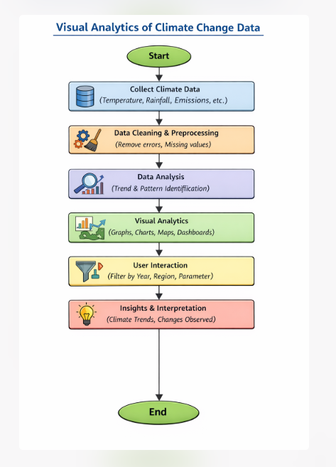

5. METHODOLOGY
The methodology explains the step-by-step process followed to analyze climate change data using visual analytics. The goal of this project is to understand the relationship between CO₂ emissions, sea level rise, and temperature changes through clear visual representations.
1. Data Collection
Climate change data is collected from reliable and publicly available sources. The datasets include information related to CO₂ emissions, global temperature levels, and sea level measurements over several years. The data is obtained in CSV format and contains both historical and recent records.
2. Data Cleaning and Preprocessing
The collected data may contain missing values, duplicate entries, or inconsistencies. In this step:
- Missing and incorrect values are removed or corrected
- Duplicate records are eliminated
- Data is formatted properly for analysis
This ensures the data is accurate and ready for further processing.
3. Data Organization
After cleaning, the data is organized into separate categories such as:
- CO₂ emissions by country and year
- Sea level measurements over time
- Temperature data across different regions
This structured format helps in easier analysis and visualization.
4. Data Analysis
The processed data is analyzed to identify patterns, trends, and relationships.
- CO₂ emission trends are studied over time
- Changes in sea level are observed using smoothed trends
- Temperature variations across countries and years are analyzed
This step helps in understanding how climate indicators change over time.
5. Visual Analytics
Visual analytics is applied to convert analyzed data into:
- Line graphs for trend analysis
- Bar charts for comparison
- Pie charts for distribution
- Dashboards for overall visualization
These visuals help in clearly understanding complex climate data.
6. User Interaction and Exploration
Users can interact with the visualizations by:
- Filtering data by year or region
- Comparing different climate parameters
- Observing specific climate trends
This improves user engagement and understanding.
7. Result Interpretation
The final step involves interpreting the visual outputs. The results clearly show that increasing CO₂ emissions are strongly linked with rising temperatures and sea levels. This confirms the impact of human activities on climate change.

- DATASET:
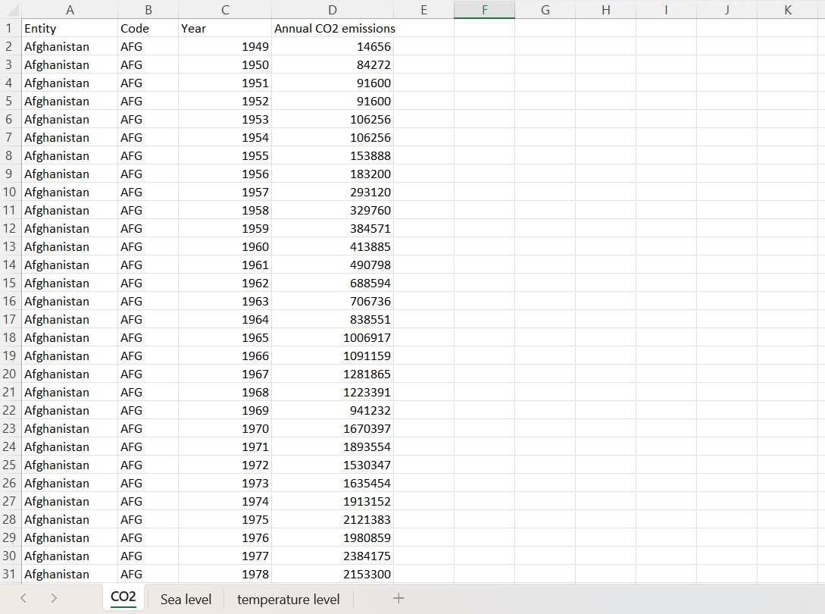
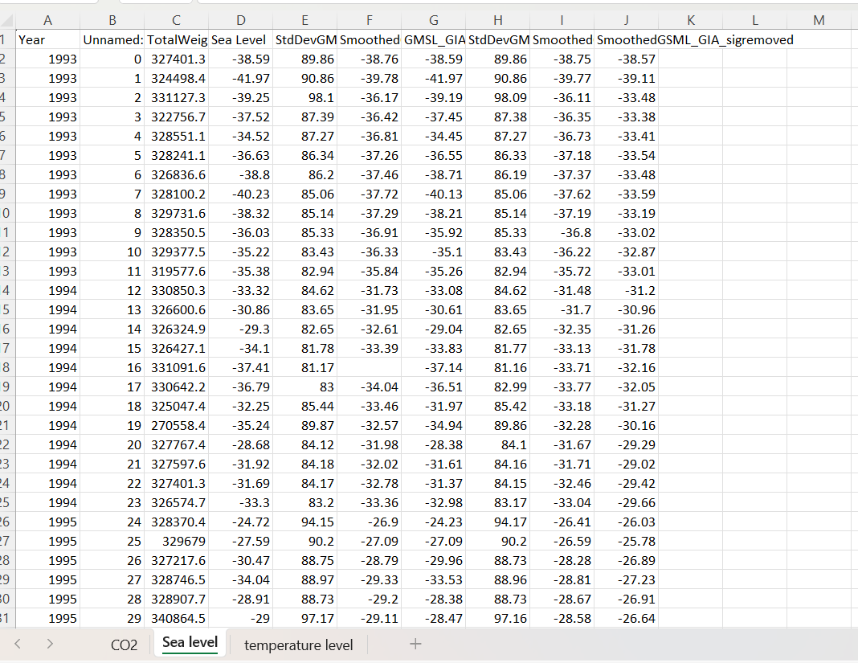
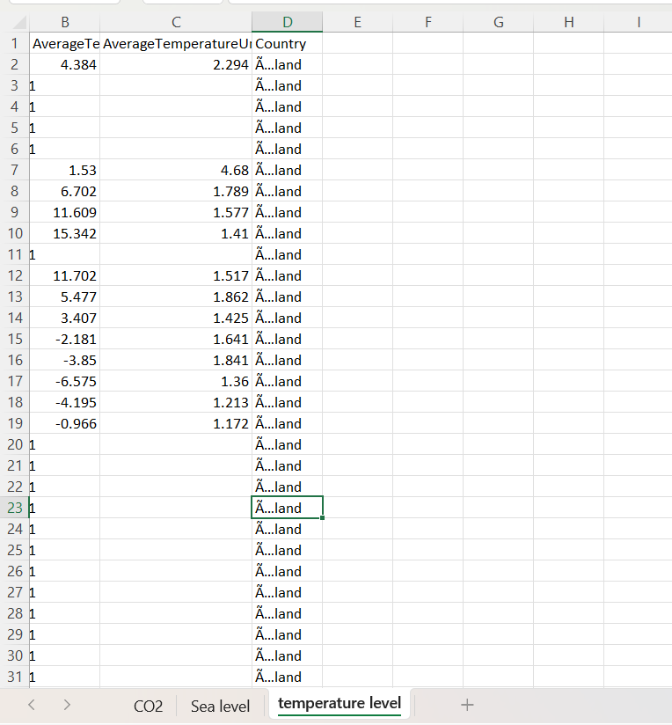

7. TESTING AND RESULTS
7.1 SAMPLE INPUTS AND OUTPUTS
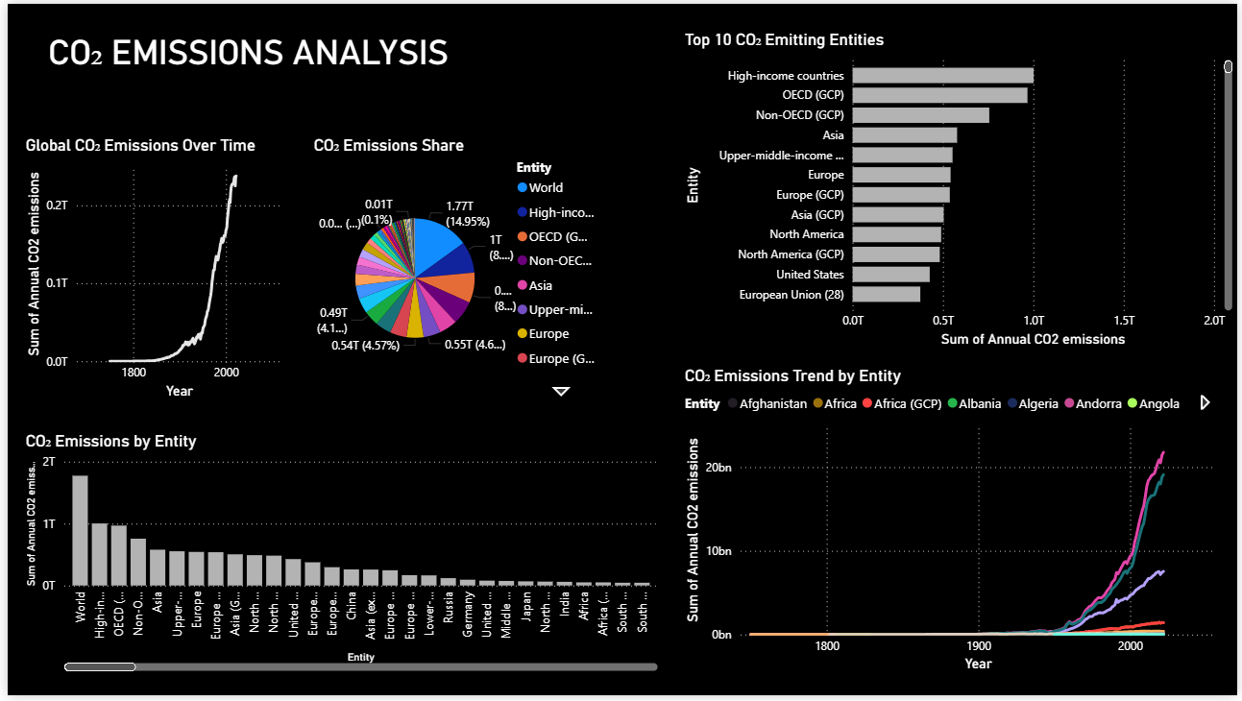
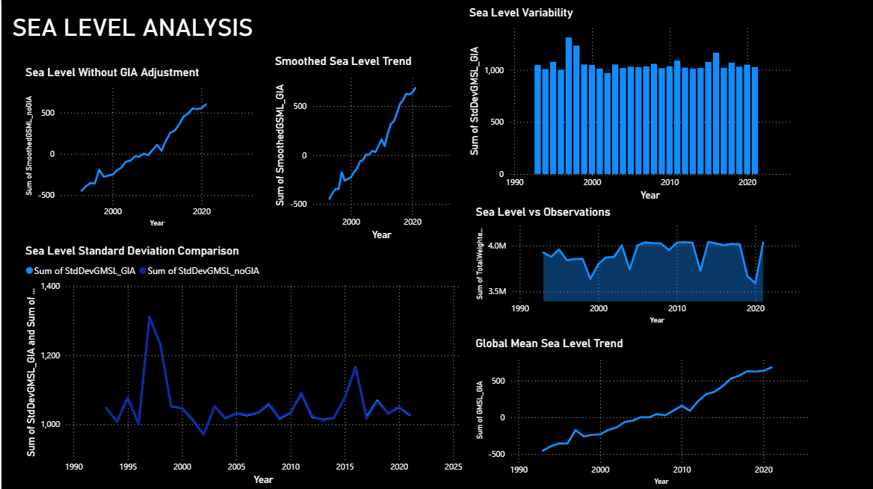

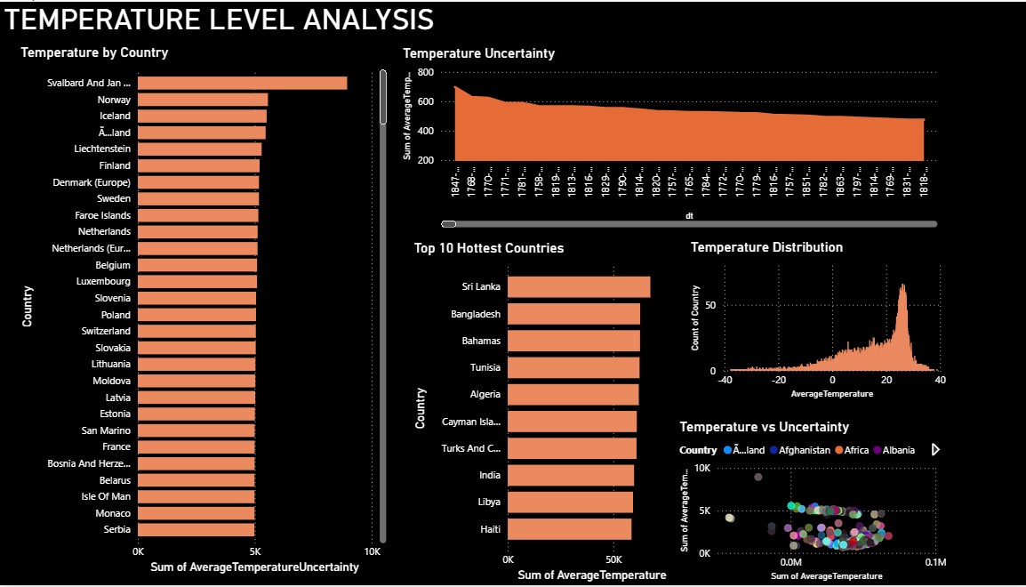

Based on the given visualizations, the results clearly support the conclusion that increasing CO₂ emissions are strongly linked with rising temperatures and sea levels.
- CO₂ Emissions Analysis:
The graphs show a sharp and continuous rise in global CO₂ emissions over time, especially in recent decades, driven mainly by industrialized and high-income regions.
- Temperature Level Analysis:
Temperature trends show an overall increase across countries and years. The distribution and trend plots indicate warming that aligns with periods of higher CO₂ emissions, not just data uncertainty.
- Sea Level Analysis:
Both raw and smoothed sea-level trends show a steady upward movement. This rise corresponds with warming oceans and melting ice, which are consequences of increased greenhouse gases.
Taken together, the visuals demonstrate a consistent pattern: as CO₂ emissions increase, global temperatures rise, and sea levels continue to climb. This confirms the statement and highlights the real, observable impacts of climate change over time.
7.2 DISCUSSION
The results of the analytics are really clear. They show that there is a strong connection between CO₂ emissions and sea level rise and temperature changes. This shows what a big impact climate change has over time. Climate change is something that affects us a lot. The connection, between CO₂ emissions and climate change is very important to understand.
The CO₂ Emissions Analysis shows that the amount of CO₂ in the air is going up fast especially since people started working in factories and stuff. Countries with a lot of money and big factories are making most of the CO₂. If you look at the graphs you can see that CO₂ is going up fast in the last few decades. This is because people are using energy and relying on things like coal and oil. The CO₂ Emissions Analysis makes it clear that things people do are making the Earth get warmer. The CO₂ emissions are still going up. This is a big problem, for the Earth. The Sea Level Analysis shows that the sea level is going up all the time. When we look at the smoothed trends of the sea level we can see that it is always going up. The Sea Level Analysis really proves that the sea levels are going up steadily over time. We also see some ups and downs in the sea level trends. The main thing is that the sea level is still rising. This rise, in the sea level is closely linked to the melting glaciers and the oceans getting warmer because of global warming.
The Sea Level Analysis is important because it helps us understand what is happening to the sea levels over the years. The Temperature Level Analysis helps us see that things are getting hotter. We are seeing average temperatures. Some countries are really hot the ones near the equator and in poorer areas. As we get better at measuring temperature we are not as unsure about what the temperature's. Even with better measurements the Temperature Level Analysis still shows that the temperature is going up. When we look at the temperature and how sure we are about it we can see that the Earth is really getting warmer and it is not just because of mistakes, in our data. The Temperature Level Analysis makes it clear that the temperature is rising.
These visualizations make complex climate data easy to understand and clearly demonstrate that increasing CO₂ emissions are associated with rising temperatures and sea levels. The discussion confirms the effectiveness of visual analytics in identifying climate trends and emphasizes the urgent need for emission reduction and climate mitigation strategies.

8. CREATIVITY & INNOVATION

- The project creatively combines multiple climate factors such as CO₂ emissions, sea level rise, and temperature data into a single visual analytics dashboard.
- Instead of showing raw numbers, the system uses interactive graphs, charts, and maps to present complex climate data in an easy and understandable way.
- The use of trend lines, comparisons, and visual filters allows users to explore climate changes across different years and regions creatively.
- The project innovatively links human activities (CO₂ emissions) with natural impacts (temperature rise and sea level increase) through visual relationships.
- Smoothed trends and uncertainty visualizations help in better interpretation of climate patterns, which is rarely shown in basic analysis systems.
- The dashboard design focuses on visual storytelling, helping users clearly see how climate change has progressed over time.
- The project introduces a user-friendly approach that allows even non-technical users to interact with and understand climate data.
- The system can be extended with real-time data, AI-based predictions, and interactive alerts, showing strong potential for future innovation.

9. COMMUNITY IMPACT
The Visual Analytics of Climate Change Data project has a positive impact on different groups of people:
1. For general public and citizens:
Many people find climate change data difficult to understand because it is shown in numbers and reports. This project helps citizens easily understand climate issues by using graphs, charts, and maps. People can clearly see changes in temperature, CO₂ emissions, and sea levels, which increases awareness and understanding.
2. For students and learners:
This project helps students understand how climate data can be analyzed using visual analytics. It connects theoretical knowledge of data analysis with real-world climate problems. Students gain practical experience in working with datasets, visualizations, and interpretation of results.
3. For teachers and educators:
Educators can use this project as a teaching tool to explain climate change concepts and data analysis techniques. Visual representation makes learning more engaging and easier compared to traditional textbook methods.
4. For researchers and analysts:
Researchers can use the visual insights to study climate trends more efficiently. The project helps in identifying patterns, comparing regions, and understanding long-term climate changes without manually analyzing raw data.
5. For policymakers and planners:
The project supports better decision-making by presenting climate data in a clear and visual form. Policymakers can use the insights to plan environmental policies, climate action programs, and sustainability initiatives.
6. For local communities:
Local communities can understand how climate change affects their region, such as rising temperatures or sea-level risks. This helps communities prepare for climate-related challenges like floods, droughts, and extreme weather.
7. For environmental awareness programs:
The project can be used in awareness campaigns to show the real impact of human activities on climate change. Visual data makes messages stronger and more convincing.
8. For the wider society:
The project requires only basic computing tools and freely available data, making it accessible to a wide audience. It promotes environmental responsibility and shows how technology can be used to address global challenges like climate change.

10. REFERENCES
- Intergovernmental Panel on Climate Change (IPCC), Climate Change 2021: The Physical Science Basis, Cambridge University Press, 2021.
- NASA Earth Observatory, Global Climate Change: Vital Signs of the Planet, NASA, USA.
- National Oceanic and Atmospheric Administration (NOAA), Climate Data and Global Warming Indicators, NOAA, USA.
- World Bank, World Development Indicators – Climate Change Data, World Bank Publications.
- Few, S., Information Dashboard Design: Displaying Data for At-a-Glance Monitoring, Analytics Press, 2013.
- Keim, D. A., Kohlhammer, J., Ellis, G., & Mansmann, F., Mastering the Information Age: Solving Problems with Visual Analytics, Eurographics Association, 2010.
- Heer, J., Card, S. K., & Landay, J. A., “Prefuse: A Toolkit for Interactive Information Visualization,” Proceedings of the SIGCHI Conference on Human Factors in Computing Systems, 2005.
- Matplotlib Documentation, Visualization with Python, https://matplotlib.org
- Pandas Documentation, Data Analysis and Manipulation Tool, https://pandas.pydata.org
- Tableau Software, Data Visualization for Climate and Environmental Analysis, Tableau Public Resources

